**Control system**

**Assignment :-1 Unit one**

1. Draw the block diagram and then determine the transfer function of the given networks.

C2

R

R

C1

Vi

Vo

+

-

C2

L

C1

Vi

Vo

Fig 1 fig 2

 

1. Determine the overall transfer function with the help of signal flow graph and block diagram approach technique of the following.

-

+

-

+

+

R

C

H1

G2

G1

(i)

 Fig 3

-

-

+

-

+

+

+

+

+

+

R4

R3

R2

H1

C

H2

G2

G1

R1

(ii)

 Fig 4

-

-

+

+

+

+

+

R

C

G4

H1

H2

G3

G2

G1

-

(iii)

Fig 5



G2

G3

-1

H2

R

C

1

1

1

H1

G4

G1

1. Obtain C/R ratio for a system whose signal flow graph is represented by following figure

 Fig 6

1. 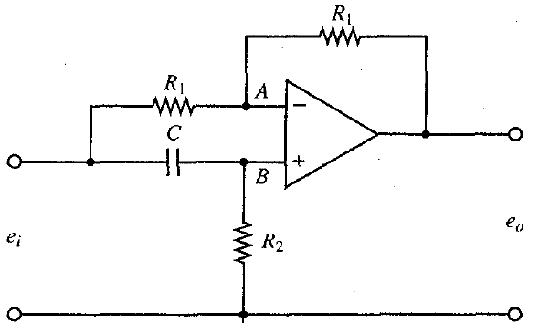Using the Impedance approach find the transfer function Eo(s)/Ei(s) shown in fig(7).

Fig 7

1. Obtain the Transfer functions X1(s)/U(s) and X2(s)/U(s) of the mechanical system shown in fig(8).

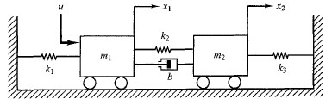

Fig 8

1. What is servo mechanism? Explain Position Control system in brief.
2. Calculate the sensitivity of the closed loop system shown in figure 9 w.r.t.
   1. The forward path transfer function
   2. Feedback path transfer function

At ω=1.3 rad/sec

-

+

R

C

0.40

10/(s2+3s)

Fig 9



1. For a position control system using DC servomotor in the armature control mode shown in figure 10, assume that gain constant K is 10, α is 2, and feedback parameter β is 1, evaluate the sensitivities , & . For a reference input of r(t)=2 cos (0.5t) and a 5% change in K, evaluate the steady sate response and hence the change in steady state response.

-

+

R

C

β

K/(s2+αs)

